

Sam Emaminejad received his BASc (2009) and MS (2011) degrees in Electrical Engineering from the University of Waterloo and Stanford University, respectively. He is pursuing his PhD in Electrical Engineering at Stanford University where he is working toward his thesis at Stanford Genome Technology Center (SGTC). Sam has previously worked as an ASIC and Analog Designer in semiconductor companies such as STMicroelectronics and Analog Devices and is the co-author of Supplemental Problems and Solutions Manual for Microelectronic Circuits (Sedra/Smith, 2013). Sam was the recipient of the Best Paper Award of the IEEE Sensors conference in 2013. His current research at SGTC is primarily focused on three projects as described below:

**1. Ultra-sensitive electronic multiplexed protein biosensor**

By integrating microfluidics with electrical impedance sensing technology we measure the abundance and functionality of a panel of protein biomarkers. To perform the multiplexed functionality, a bead-based assay is performed in an array format along single channel. Each element of the array is functionalized with a different antibody, targeting a specific antigen in the subsequently introduced sample. The captured antigen will then be sandwiched by injecting secondary antibody that is tagged with micron-sized bead. Upon performing the assay, immuno-bound beads on each element of the array are eluted selectively from the array and are quantified downstream (one element at a time). In this approach to electronically modulate the protein-protein interactions, a robust and addressable electrokinetic actuator was required. For this purpose, Dielectrophoresis (DEP) was a potential candidate as it is amenable to microfluidics applications. DEP is a force exerted on polarizable particles in a non-uniform electric field. However, conventionally, DEP devices have weak actuation forces that are significantly smaller than protein-protein interactions. Through improved nanofabrication and novel modeling and optimization techniques we have made possible the design and fabrication of high voltage, corrosion-resistant electrodes which enhanced the strength of inherently weak DEP force by two orders of magnitude.

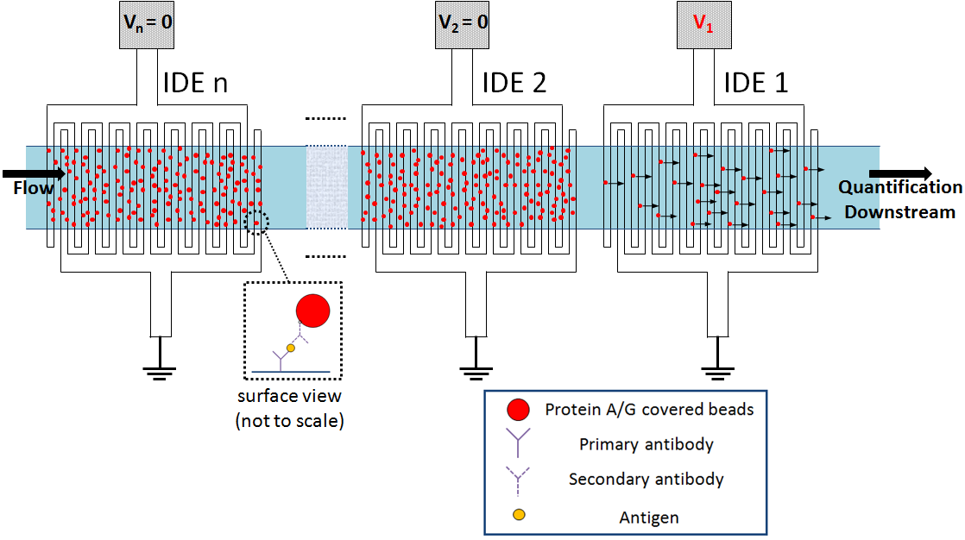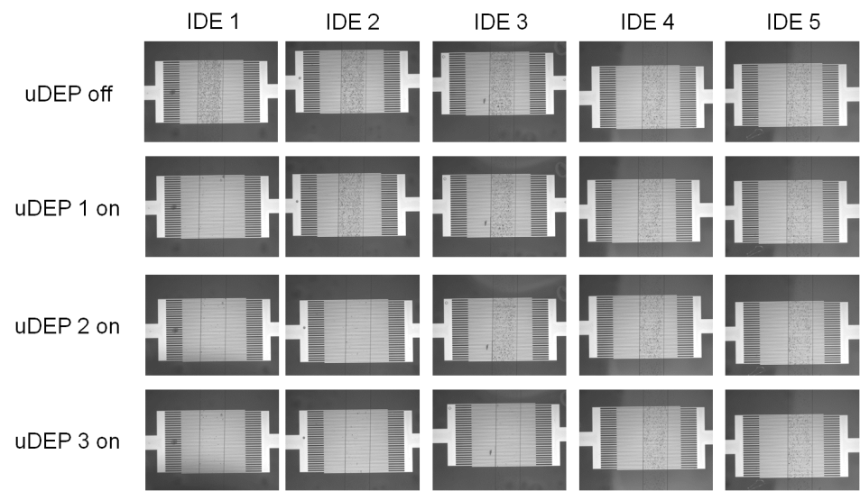

**2. Contactless impedance flow cytometry for low-cost diagnostic**

This system offers a cost-effective approach to implement a disposable microfluidic contactless impedance cytometer. Conventional methods for single cell impedance cytometry use microfabricated electrodes in direct contact with the buffer to measure changes of its electrical impedance when cells pass through the applied electric field. However, they require expensive microfabrication of electrodes, and also, the fabricated electrodes cannot be reused without thorough and time-consuming cleaning process. Here, we introduced a novel approach to allow for single cell impedance cytometry using electrodes that can be reused, without the need for microfabrication of the electrodes. This disposable device can be potentially inserted onto a printed circuit board (PCB) which has a non-disposable, yet inexpensive, electronic reading apparatus. This significantly reduces the manufacturing costs, making it suitable for low resource settings, such as point-of-care testing in the developing countries.

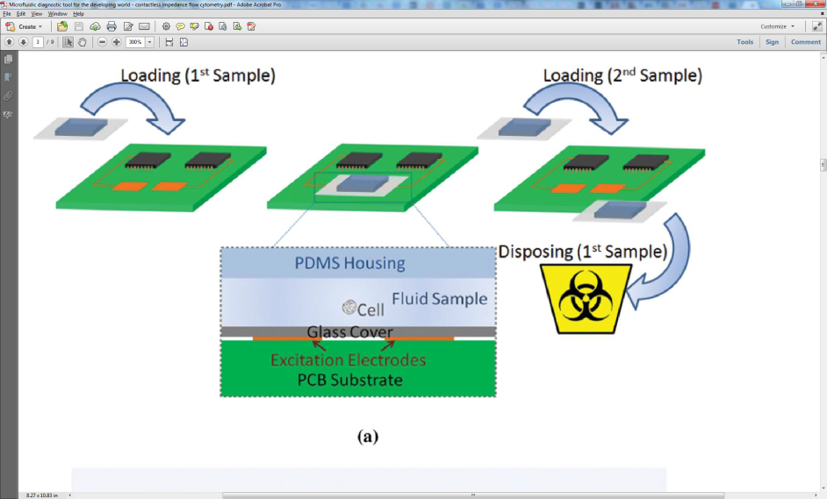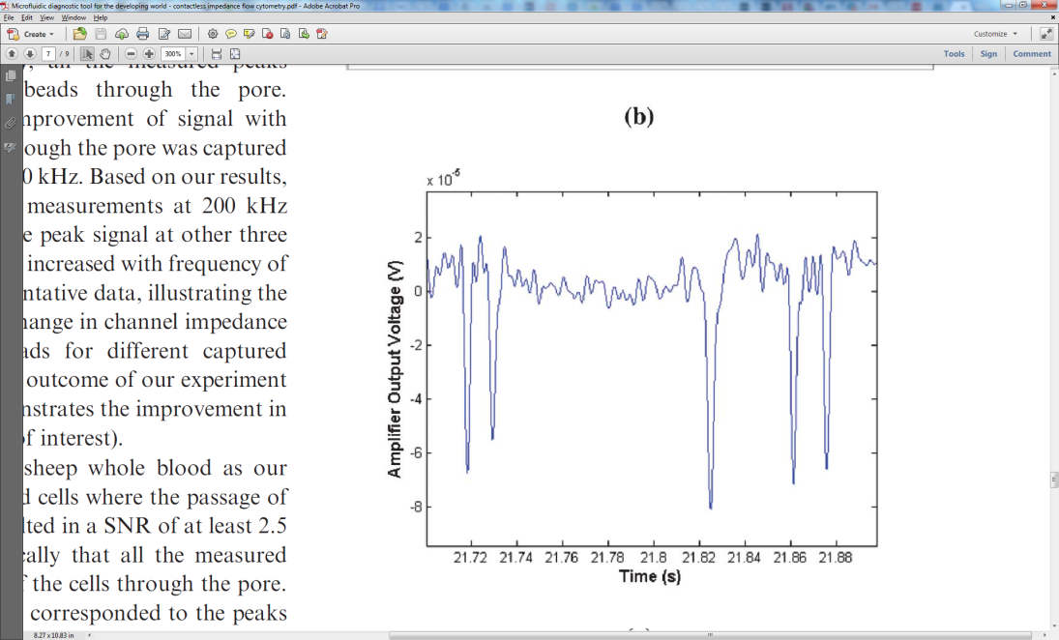

S. Emaminejad, M. Javanmard, R. W. Dutton and R. W. Davis, *Lab Chip*, 2012, **12**, 4499

**DOI:**10.1039/C2LC40759K *- Reproduced by permission of The Royal Society of Chemistry (RSC)*

**3. Sample preparation for a quantum biomolecular sensing platform**

We propose a three-component sample preparation platform for delivering proteins, with controlled orientation, purified from a complex biological sample to a sensor surface. The presented platform depletes highly abundant proteins and cells from complex biological samples, and then is capable of immobilizing the target analyte on the surface with controlled immobilization. A herringbone structure is used to mix the sample with micron-sized beads coated with antibodies against the highly abundant proteins, which is then fed into a second component, consisting of a filter trench with interdigitated electrodes above for applying dielectrophoretic force. The beads and cells are pushed down into the filter trench, thus allowing only the serum to pass through. In a third step, protein orientation and immobilization is controlled with electric field.

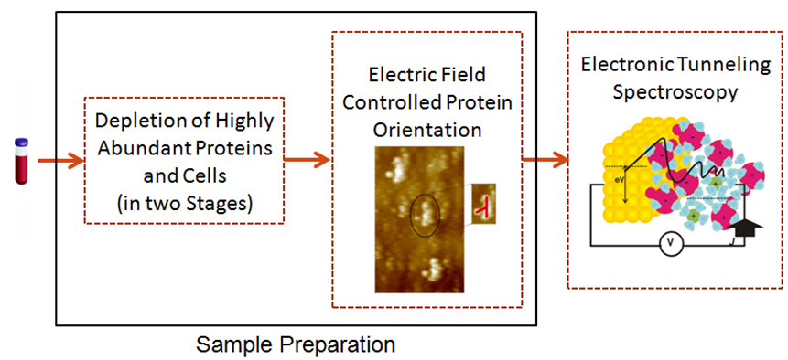

**List of Patents, Book, Journal and Conference Publications**

**[P.1]** US Provisional Patent: “Methods and Systems for Orienting Nanomaterials,” **Emaminejad, S.**, Javanmard, M.., Gupta, C, Howe R.T., Filed: October 25, 2013, Serial No: 61/895,563

**[P.2]** US Nonrovisional Patent: “Negative Dielectrophoresis for Selective Elution of Immuno-Bound Particles,”Javanmard, M., **Emaminejad, S.**, Mok, J., and Mindrinos M., Filed: September 30, 2013, Serial No: 14/044,585

**[B.1]** Sedra, A. S., Smith, K. C., **Emaminejad, S.**, *et al*. (2013). *Supplemental Problems and Solutions Manual to Accompany Microelectronic Circuits*. New York: Oxford University Press.

**[J.1]** Javanmard, M., **Emaminejad, S.**, Gupta, C., Provine, J., Davis, R. W., and Howe, R. T., (2014). [Depletion of Cells and Abundant Proteins from Biological Samples by Enhanced Dielectrophoresis.](http://www.sciencedirect.com/science/article/pii/S0925400513014500) *Sensors and Actuators B: Chemical*, 193, 918-924. *(first co-author)*.

**[J.2]** **Emaminejad, S.**, Javanmard, M., Dutton, R. W., and Davis R. W., (2013). Ultra Dielectrophoresis Using Atomic Layer Deposited Films: Electrothermal Analysis. *ECS Transactions*, *(in press)*.

**[J.3]** **Emaminejad, S.**, Javanmard, M., Dutton, R. W., and Davis R. W., (2012). [Smart Surface for Elution of Protein–Protein Bound Particles: Nanonewton Dielectrophoretic Forces Using Atomic Layer Deposited Oxides](http://pubs.acs.org/doi/pdf/10.1021/ac302857z). *Analytical Chemistry*, 84(24), 10793-10801.

**[J.4]** **Emaminejad, S.**, Javanmard, M., Dutton, R. W., and Davis R. W., (2012). [Microfluidic diagnostic tool for the developing world: contactless impedance flow cytometry](http://pubs.rsc.org/en/content/articlepdf/2012/lc/c2lc40759k). *Lab Chip*, 12(21), 4499-4507.

**[J.5]** Javanmard, M., **Emaminejad, S.**, Dutton, R. W., and Davis R. W., (2012). [Use of Negative Dielectrophoresis for Selective Elution of Protein-Bound Particles](http://pubs.acs.org/doi/abs/10.1021/ac202508u). *Analytical Chemistry*, 84(3), 1432-1438. (*first co-author*)

**[C.1]**  **Emaminejad, S.**, Javanmard, M., Gupta, C., Chang, S., Davis, R. W., Howe, R. T., “Electrofluidic Self-Assembly with Molecular Control of Orientation,” Presented at *International Semiconductor Devices Research Symposium*, Washington, D.C., MD, December 2013.

**[C.2]**  Javanmard, M., **Emaminejad, S.**, Gupta, C., Chang, S., Davis, R. W., Howe, R. T., “Three Stage Sample Preparation for Purification of Proteins from Complex Biological Samples,” Presented at *IEEE Sensors*, Baltimore, MD, November 2013 (*Best Paper Award, first co-author*).

**[C.3]**  **Emaminejad, S.**, Javanmard, M., Dutton, R. W., Davis, R. W.**,**“Multiplexed Proteomics using Ultra Dielectrophoresis (uDEP),” Presented at *2013 AIChE Annual Meeting*, San Francisco, CA, November 2013.

**[C.4]**  **Emaminejad, S.**, Javanmard, M., Gupta, C., Dutton, R. W., Davis, R. W., Howe, R. T., “Ultra Dielectrophoresis: Electrothermal Analysis and Its Applications in Microfluidic Sample Preparation and Proteomics,” Presented at *MicroTAS*, Freiburg, Germany, October 2013.

**[C.5]**  Javanmard, M., **Emaminejad, S.**, Gupta, C., Chang, S., Davis, R. W., Howe, R. T., “Immobilization of Antibodies on Solid-State Surfaces with Controlled Orientation Using Electric Field,” Presented at *MicroTAS*, Freiburg, Germany, October 2013.

**[C.6]**  **Emaminejad, S.**, Javanmard, M., Dutton, R. W., Davis, R. W.**,**“Ultra Dielectrophoresis Using Atomic Layer Deposited Films for Electronic Multiplexed Biomarker Detection,” Presented at *Electrochemical Society Symposium*, San Francisco, CA, October 2013.

**[C.7]**  **Emaminejad, S.**, Javanmard, M., Dutton, R. W., Davis, R. W.**,**“Application of Ultra Dielectrophoresis (uDEP) for Multiplexed Proteomics,” Presented at *Biomedical Engineering Society Annual Meeting*, Seattle, WA, September 2013.

**[C.8]** **Emaminejad, S.**, Javanmard, M., Gupta, C., R. W. Davis, Howe, R. T., “[Applications of Ultra-Dielectrophoresis to Sample Preparation and Proteomics](ftp://pmmiconferences.com/TRANS_Manuscripts/0254_TRANS13_Emaminejad_1.pdf),” *Proceedings of the 2013 IEEE Transducers Conference*, Barcelona, Spain, June 2013.

**[C.9]** Javanmard, M., **Emaminejad, S.**, Dutton, R. W., R. W. Davis, “Contactless Impedance Sensing: Low Cost Cellomics and Proteomics for the Developing World,” Presented at *Microtechnologies in Medicine and Biology*, Marina Del Rey, CA, April 2013.

**[C.10]** Javanmard, M., **Emaminejad, S.**, Gupta, C., Provine, J., Davis, R. W., Howe, R. T., “Microfluidic Sample Preparation Platform for Depletion of Cells and Highly Abundant Proteins from Blood,” Presented at *Materials Research Society Spring Annual Meeting*, San Francisco, CA, April 2013.

**[C.11]** **Emaminejad, S.**, Javanmard, M., Dutton, R. W., Davis, R. W., “Two Order of Magnitude Improvement in DEP force using ALD Deposited Oxide,” Presented at *Materials Research Society Spring Annual Meeting*, San Francisco, CA, April 2013.

**[C.12]** **Emaminejad, S.**, Javanmard, M., Dutton, R. W., Davis, R. W., “Contactless Impedance Sensing for Flow Cytometry,” Presented at *Materials Research Society Fall Annual Meeting*, Boston, MA, November 2013.

**[C.13]** Javanmard, M., **Emaminejad, S.**, Dutton, R. W., Davis, R. W., “Cell Counting Using Contactless Impedance Sensing For Low Resource Settings,” Presented at *Biomedical Engineering Society Annual Meeting*, Atlanta, GA, October 2012.

**[C.14]  Emaminejad, S.**, Javanmard, M., Dutton, R. W., Davis, R. W.**,**“Disposable Coded Low Signal-Noise Ratio Single Cell Impedance Cytometry,” Presented at the *Nanotech*, Santa Clara, CA, June 2012.

**[C.15]**  Javanmard, M., **Emaminejad, S.**, Dutton, R. W., Davis, R. W., “[An Electronic Microfluidic Switch Using Dielectrophoresis for Control of Microparticles](http://ieeexplore.ieee.org/xpl/abstractKeywords.jsp?arnumber=6135210),” Presented at *International Semiconductor Devices Research Society*, College Park, MD, December 2011.

**[C.16]**  **Emaminejad, S.**, Javanmard, M., Dutton, R. W., Davis, R. W., “[Smart Surfaces: Use of Electrokinetics for Selective Modulation of Biomolecular Affinities](http://journals.cambridge.org/action/displayAbstract?fromPage=online&aid=8479111),” *Proceedings of Materials Research Society*, Boston, MA, November 2011.

**[C.17]**  Javanmard, M., **Emaminejad, S.**, Dutton, R. W., Davis, R. W., “[Use of Negative Dielectrophoresis for Selective Elution of Immuno-bound Particles](http://www.rsc.org/images/LOC/2011/PDFs/Papers/645_0660.pdf),” *Proceedings of MicroTAS*, Seattle, WA, October 2011.